Case 5-Asia-China-Ming-Phoenix Crown Pendant-鳳冠-fèngguān-1368–1644

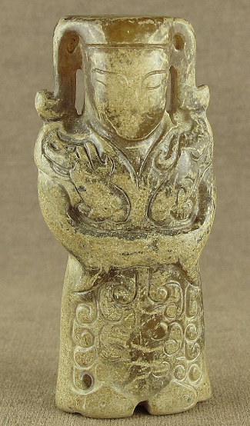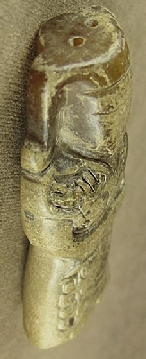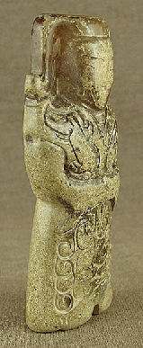

Figs. 1-3. China-Phoenix Crown Pendant-鳳冠-fèngguān-Ming Dynasty-1368–1644

**Case no.: 5**

**Accession Number:**

**Formal Label:** China-Phoenix Crown Pendant-鳳冠-fèngguān-Ming Dynasty-1368–1644

**Display Description:**

This is a jade figurine of an early Ming imperial wife (14th- 15th c) wearing a 鳳冠 [fèngguān](https://en.wiktionary.org/w/index.php?title=f%C3%A8nggu%C4%81n&action=edit&redlink=1) (P) or Phoenix crown which would have been decorated with extremely rare emerald kingfisher feathers that would have protruded as "emerald tips" 點翠 Tian-tsui (WG), diǎncuì, (P). The 'wings' 兩博鬢, liǎngbóbìn (P) on the sides of the coronet would have been made of kingfisher feathers, and decorated with pearls and gemstones. The Ming Dynasty (1368–1644) was predicated on extreme order, especially in the display of symbolism such as this coronet and the gown worn with it, which has cloud or heaven symbols 霄signifying that the person wearing it is at the highest level of the social order, the Heavenly realm. This figurine is a pendant and would have been brandished only by a Ming imperial wife. Its burnished aspect is an attestation to the fact that it was displayed for a long time.

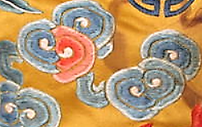

Fig. An example of cloud embroidery on a royal robe. Lot 951 **AN IMPERIAL YELLOW SATIN DRAGON ROBE EMBROIDERED WITH FIVE IMPERIAL SYMBOLS**

**19th century** **Sold for US$ 60,000 inc. premium**

**[Bonhams FINE ASIAN WORKS OF ART](https://www.bonhams.com/auctions/24265/)**

18 Dec 2017, 11:00 PST

[SAN FRANCISCO](https://www.bonhams.com/locations/SF/)

**LC Classification:**

**Date or Time Horizon:** 14th- 15th c

**Geographical Area:** Nanjing

**Map:**

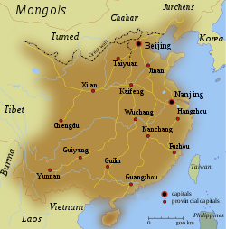

**GPS coordinates:**

**Cultural Affiliation:**

**Media:**

**Dimensions:**

**Weight:**

**Condition:**

**Provenance:**

Discussion:

One of the earliest phoenix crowns that has been excavated belonged to [Empress Xiao](https://en.wikipedia.org/wiki/Empress_Xiao_(Sui_dynasty)) of the [Sui dynasty](https://en.wikipedia.org/wiki/Sui_dynasty) (581-618) (China Daily 2016) It became most popular during the [Ming Dynasty](https://en.wikipedia.org/wiki/Ming_Dynasty).

Unlike the original crown, its replica glitters under the light of the showcase. Professor Yang said the replica has the original appearance of the ancient crown, including 12 water-drop shaped headwear, as well as 13 follower plants and 166 petal shaped ornaments.

The crown reveals the highly sophisticated technology of making gilded bronze art crafts in Chinese Sui and Tang Dynasties.

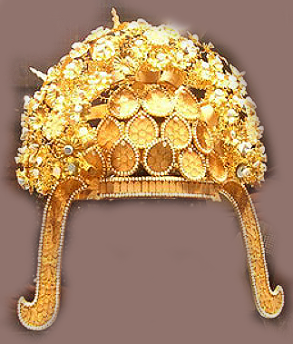

A replica of Empress Xiao's phoenix crown on display at the Yangzhou Museum in Jiangsu province. Photo after Chinanews.com.

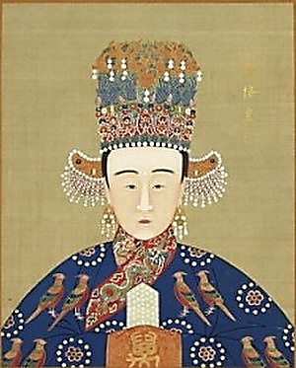

An example of a Ming Dynasty Empress wearing a phoenix XiaoKe.jpg

**References:**

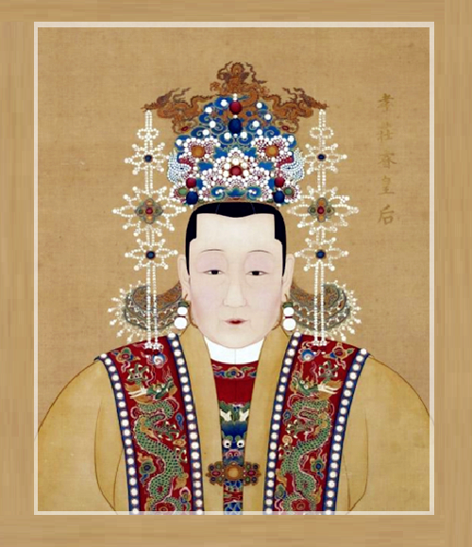

https://www.ancienthistorylists.com/wp-content/uploads/2016/06/Phoenix-crown.x34319.png